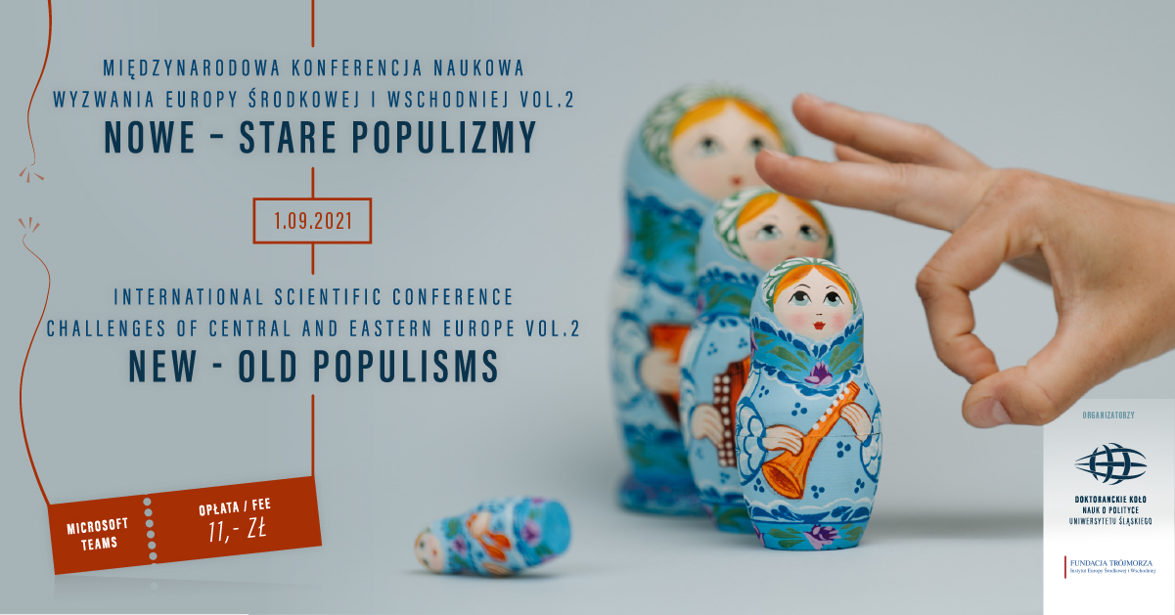

It is said that history comes full circle. The statement may certainly be considered valid once we analyze the increasing popularity of European populist political movements.
Due to the mediatization of politics, a growing sense of alienation of certain social groups,
as well as the crisis of conservative family model and social changes, hardly anyone is interested in political agendas. More and more often elections are won thanks to catchy slogans.
Contemporary populism differs from the “traditional” one. Nowadays, all kinds
of information are widely accessible. Social media allows us to comment on the actions taken
by politicians or to verify their communications. It is worthwhile to ask the question of why currently political populism guarantees electoral success.
The organizers of the conference encourage students, PhD candidates and professors
to discuss the above-described phenomenon. We invite especially political scientists
and historians to participate in the event. However, due to the interdisciplinary character of the conference, researchers representing other disciplines are also welcome to send their proposals.
Any issue may be raised in your speech. Nevertheless, we are especially interested
in the following topics:
- History of populist movements over the centuries
- Role of the leader of a populist movement
- Historical backgrounds which determine the development of populisms
- Popularity of populist literature
- Populism in old and new media
- Ideal type of traditional and contemporary populist
- Difference between demagogy and populism
- Populist movements and degeneration of leadership
- Deepfake and populism
- Populisms seen through the eyes of elites
- Phenomenon of populism in the selected countries of Central and Eastern Europe
                - Populism in politics
- Populism in economics
- Future of populisms
- Profile of a populist movements’ sympathizer

The conference will be held September 1, 2021 online via the platform MS Teams.
The conference fee covers the price of a certificate and its shipping. The shipping cost to Poland is 11 PLN. In case of an international parcel, the cost will be determined individually.
The conference fee should be transferred to the account number PL 26 1140 2017 0000 4102 1286 5244 (Recipient: Zuzanna Sielska) by August 15, 2021. Please enter your name, surname and "Conference fee" in the transfer title, e.g. Jan Kowalski Conference fee.
Both speakers and listeners may enroll for the conference submitting the form available at: https://docs.google.com/forms/d/1S1WHZQc0iik0ezd58qVDUOc6ATDNRc5VoxZaQ4IRE6A/editYou may also send an email to challenges.wns@us.edu.pl. Your participation request should contain:
• Name, surname and affiliation,
• Title of the speech,
• Summary - approx. 500 characters,
• E-mail address,
• Correspondence address.

We await your proposals until August 15, 2021, 23:59 PM UTC+2.
The Organizers:


