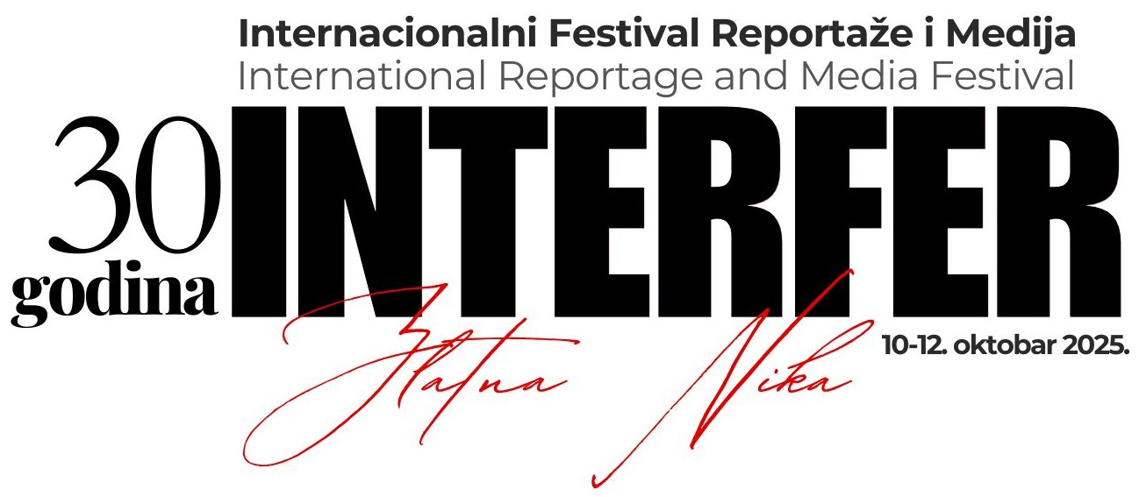

PRIJAVA - APPLICATION FORM

KATEGORIJA / CATEGORY:

ORIGINALNI NAZIV / ORIGINAL TITLE:

IME AUTORA / AUTHOR'S NAME:

TRAJANJE, DUŽINA / RUNNING TIME, LENGHT:

DRŽAVA, GRAD / COUNTRY, CITY:

PRODUKCIJA I GODINA PROIZVODNJE / PRODUCTION AND YEAR OF PRODUCTION:

EMITOVANO, OBJAVLJENO (GDE, KAD) / BROADCASTED, PUBLISHED:

KONTAKT OSOBA / CONTACT PERSON:

ADRESA / ADDRESS:

TELEFON / PHONE:

E-MAIL:

KRATAK SINOPSIS / SHORT SYNOPSIS:

KRATKA BIOGRAFIJA AUTORA / SHORT BIOGRAPHY:

OPŠTI USLOVI KONKURSA

TRAJANJE - DUŽINA (running time - lenght):

- TV reportaža - do 40 min (Video reportage - up to 40 min)
- Foto reportaža - do 8 fotografija (Photo reportage - up to 8 photos)
- Novinska reportaža - do 6 strana (Newspaper reportage - up to 6 newspaper pages)
- Radio reportaža - do 30 min (Radio reportage - up to 30 min)
- Društveno odgovorna reportaža/akcija (Socially responsible reportage/activity - up to 30 min or 6 pages)

Reportaže i prijavu poslati putem mail-a: interfertv@gmail.com
(Reportages with the application should be sent by mail to interfertv@gmail.com)

Rok za prijave je 25. septembar 2025.
(Application deadline is 25th of September 2025.)

Ukoliko reportaža bude nagrađena, autor se obavezuje da prisustvuje ceremoniji uručenja nagrade.
(If awarded, the author is obliged to participate the ceremony)

Konkurs je otvoren za sve autore sveta: novinare, reportere, reditelje, medijske stvaraoce, TV i video produkcije, novinske i druge medijske kuće, fizička i pravna lica itd.
(The competition is open to all authors of the world: journalists, reporters, directors, media artists, TV and video productions, newspaper and other media companies, individuals and legal entities etc.)

Autor može da prijavi najviše jednu reportažu u jednoj takmičarskoj kategoriji.
(Author cannot register more than one reportage in one category)

Za učešće na festivalu INTERFER organizator ne naplaćuje kotizaciju.
(INTERFER does not charge the fee of participation)

Sve reportaže koje nisu sa srpskog ili engleskog govornog područja moraju biti titlovane/prevedene na engleski jezik. (All reportages from non Serbian or English speaking countries must be subtitled/translated in English)

Autor se obavezuje da pošalje jednu svoju i do tri fotografije iz reportaže za medijsku prezentaciju.
(The author is obliged to send his photo, and up to 3 photos of the reportage for the media presentation)

Organizator zadržava pravo korišćenja festivalskih reportaža i njihovih delova u svrhu promocije i prezentacije
INTERFERA. Reportaže mogu biti objavljene na sajtu INTERFERA i u drugim medijima.
(The festival reserves the right to use the sent materials and their parts for the promotion and presentation of
INTERFER. Reportages may be published on INTERFER website, etc.)

Ovom prijavom autor reportaže potvrđuje da ima sva autorska prava nad svojom reportažom, kao i da su regulisana sva autorska i druga prava u vezi njegove reportaže i da je on u potpunosti odgovoran za reportažu i njen sadržaj.
(By filling this application, author of the reportage confirms that he has all ownership rights in their materials, which are regulated in all copyrights and other rights, and he is fully responsible for the reportage and its contents)

Neće biti uvrštene u festival one reportaže koje na bilo koji način vređaju univerzalna prava ljudi i naroda, pre svega nacionalna, verska, rasna, polna prava i civilizacijske norme.
(Reportages that in any way offend the human and national rights, religious, racial, sexual rights and the social norms, will not be included into the festival)

Reportaže koje pristignu na konkurs se ne vraćaju.
(Received reportages will not be returned)

Za poslate reportaže organizator neće isplaćivati naknade autorima.
(For the sent reportages the organizer will not pay compensation to the authors)

Učestvovanjem na konkursu autor prihvata pravila i propozicije festivala.
(By participating in the contest, the author accepts the rules and regulations of the festival)

Nekompletne prijave neće biti razmatrane.
(Incomplete applications will not be considered)

Slanjem prijave, autor je saglasan sa navedenim uslovima festivala.
(By submitting the application form, the author accepts the rules and regulations of the festival)

Organizacioni odbor
Festival INTERFER

